SAN FRANCISCO STATE UNIVERSITY

SCHOOL OF ENGINEERING

Final Project Report: Motion Estimator

ENGR 852-01

Fall 2025

By

Chuan Li, #924320342
cli43@sfsu.edu
Dahlen Lakin, #911161763
dlakin@sfsu.edu
Oscar Barajas, #918234621 amodan1@mail.sfsu.edu

Date report submitted: Dec. 20, 2020

Table of Contents
Problem Analysis 3
Hardware Design 3
Verification 5
Synthesis 10
Physical Design 14
Sign-Off 19
Discussion 21
Conclusion 21

Problem Analysis: Today’s world depends very heavily on video files especially since a majority of human communication is currently virtual. Videos are now being used everywhere, from the movie industry all the way to education. Especially with the rise of 4K (and soon 8K), video sizes are getting larger than ever, making it increasingly difficult to share and store on
one’s computer. This is what makes the practice of Motion Estimation is so important. Instead of simply storing each pixel for each frame, one can instead calculate and store the much more portable motion vector of subsequent frames, drastically decreasing file size.
We are tasked to implement this device using an Application Specific Integrated Circuit. By implementing the Motion Estimator using dedicated hardware, we have the potential to increase efficiency over a software implementation using algorithms. The 32/28nm CMOS Library will be used when designing the physical layout of the chip. As for the motion estimator itself, the design will be capable of reading a 16x16 Reference Frame coded in an 8-bit Grayscale. The subsequent Search Frame for which we will be determining the motion displacement vector will have dimensions 31x31 also coded in Grayscale. Only the 260MHz Clock is available to us, and we will have to meet the minimum search speed of 15 Frames/Second.
Hardware Design: Before writing a Verilog module to implement this Motion Estimator, we must first plan out the behavioral structure of our design. This will reduce the likelihood of creating bugs in the design. A Black-Box representation of our design can be seen below in Figure 1.

Clock Start
4
8

Motion Estimator
8
8
4
8
R

S1 S2
BestDist motionX
motionY
8
10

AddressR AddressS1 AddressS2
10

Figure 1 - Motion Estimator, Black Box Representation

As indicated above, all operations will take place on the rising edge of the clock signal as opposed to using a level-sensitive latch-based design. A start signal will signal the Motion Estimator to begin executing calculations when the start signal is high. Note, our memories R, S1, and S2 (representing Reference Frame and two Possible Search Frames) are external to the Motion Estimator and will not be included in our final design. Therefore, we will have to access

the memory contents as input signals to the Motion Estimator, making it possible to switch out different memories to compute Motion Estimation on. Our design will be capable of calculating the amount of distortion seen on subsequent frames, allowing us to deduce how similar two frames really are. The estimated motion vectors for the X and Y axis will be in Two’s Compliment form, meaning that motion can range anywhere from -8 to 7 pixels.
Fortunately, we have several reference materials available to us on how to compute the Motion Vectors. We will be using the most commonly used Block Matching Algorithm to implement the Motion Estimator. The way that this algorithm works is that a frame comparison must be made between Reference and Search frames for each possible position of the Reference Frame. If the frame comparison yields low distortion, the vector describing the movement of the original reference frame to that position on the search frame will be saved as the estimated motion until a comparison yielding an even lower distortion is found.
In order to calculate this distortion, we will first have to implement a Processing Element capable of determining an accumulated distortion value based on the difference between the R memory and either S1 or S2 depending on which memory we want to use. If the distortion is greater than the maximum value allowed by 8 bits (255), distortion will simply saturate at this maximum value. To acheive the required speed of our motion estimator, we will utilize Pipelining by having 16 Processing Elements working in Parallel, though with the Reference Memory
‘pipelining’ through each one.
Then, we must make a Comparator Module that will receive the 16 distortion values from the Processing Elements (all accumulated into one long vector) and determine whether they are smaller than the currently saved value, initially set to the maximum value of 255. If distortion is smaller, we will save the frame displacement as our motion X and Y vectors.
Next, to generate all of the signals that will start calculating and comparing new distortion values, accessing memory addresses, etc., we will implement a controller that will mimic the behavior of a reference block moving through each possible position of a search block.
Finally, all of these modules will be brought together in one top module like the one shown in Figure 1.

I . Verification
- VCS
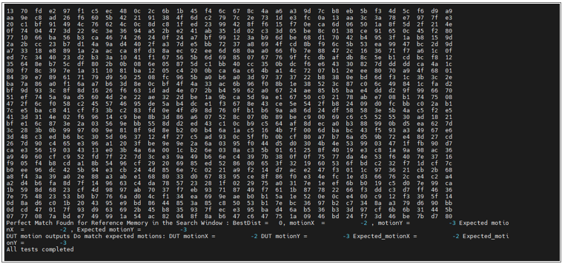

Figure 2 – VCS Verification

There are three main steps in debugging the design, which are as follows
1. Compiling the Verilog/VHDL source code.
2. Running the Simulation.
3. Viewing and debugging the generated waveforms.

In this step, the design and testbench are compiled using Synopsys VCS. During compilation, VCS checks the design for syntax errors, module connectivity, and signal mismatches as shown in Figure 2. If the design does not compile successfully, the simulation cannot proceed, so this step ensures that the RTL is structurally correct and ready to execute.

- Testing Input:

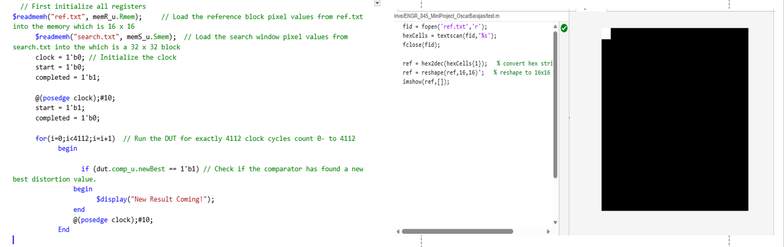

Figure 3 – Input Text Files

The testbench begins by loading two input files using the $readmemh command.
The first file in Figure 3, ref.txt, is loaded into the reference memory and represents a 16 by 16 reference image block. This block contains the pixel pattern that the design is trying to locate.

The second file in Figure 3, search.txt, is loaded into the search memory and represents a 32 by 32 search window. This larger window defines the region where the reference block is searched for possible matches.

- Functional Verification
  - Worst case

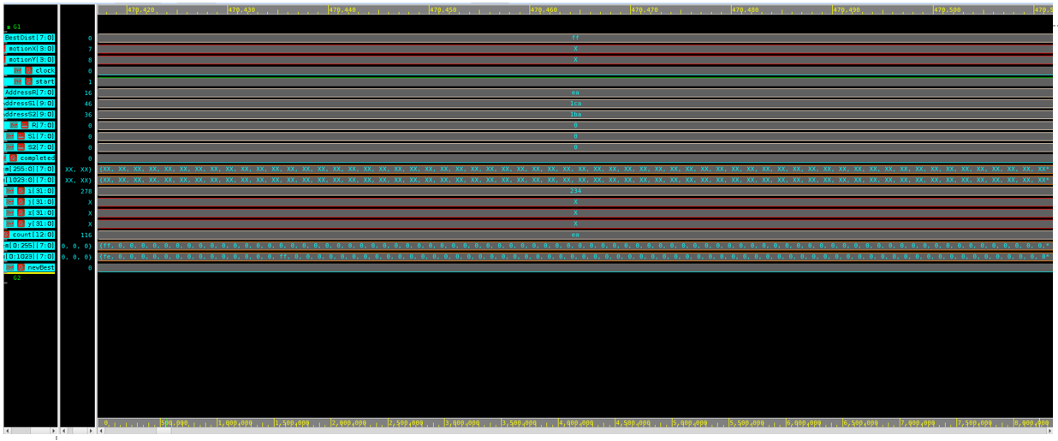

Figure 4 – Worst Case Waveform

Figure 4 shows the waveform during the first few clock cycles of the motion estimation process.
At this early stage, we can see that the BestDist signal is equal to 8'hFF, or 255, which corresponds to the output message, “Not Found the frame in the Search Window.” This waveform represents the worst-case scenario during functional verification of the motion estimator.

  - Better case
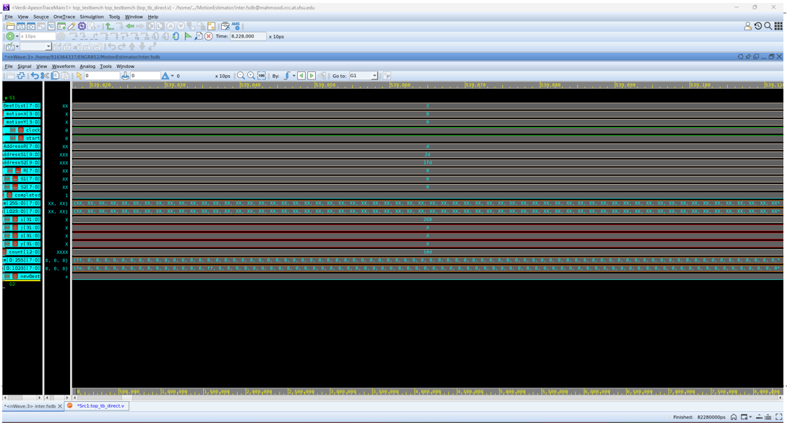
Figure 5 – Better Case Waveform

In this Figure 5, BestDist equals 2 which is non zero number but not zero , indicating a partial match that is close to the reference image, which correctly triggers the “Almost Found the frame in the Search Window” message.

  - Best Case

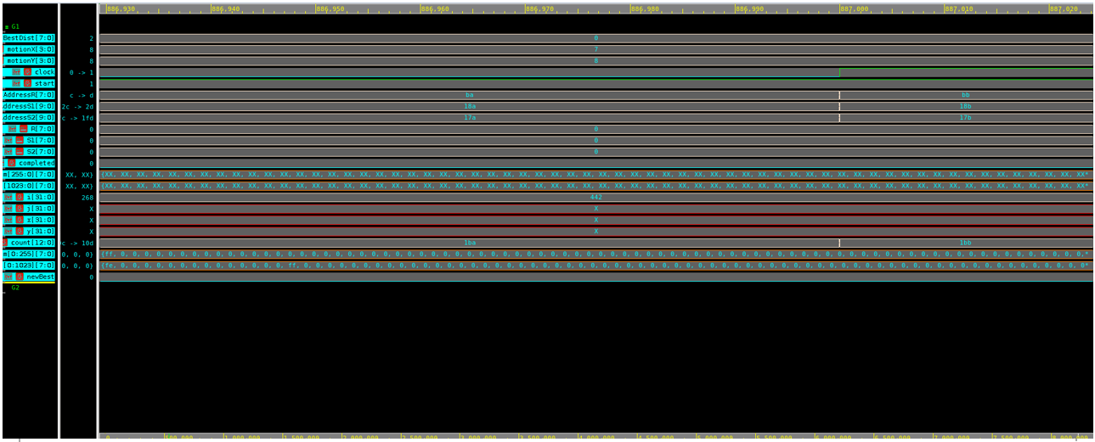

Figure 6 – Best Case Waveform

Figure 6 represents the best-case scenario in the functional verification of the motion estimator. In this case, the BestDist signal equals zero, meaning the value of BestDist is exactly 0 A BestDist value of zero indicates a perfect match between the 16×16 reference block and a selected 16×16 block within the search window

II. Synthesis

- Constraints

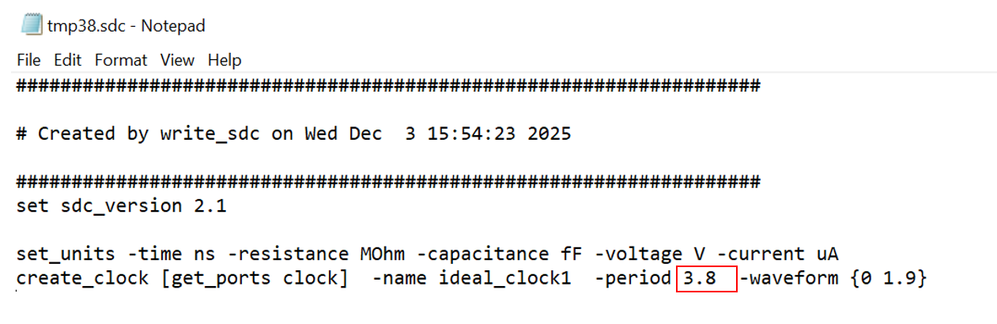
Figure 7 – sdc File

For synthesis, we use Synopsys Design Compiler within the dc_shell-xg-t environment, which provides access to the technology libraries containing all standard cells and gates. We then import our RTL using the analyze and elaborate lines of code to build the structural representation of the design as seen in Figure 7. After applying a clock constraint with create_clock, we evaluate the timing slack. Through this analysis, we determined that a 3.8-nanosecond clock period was appropriate for our design.

- Power and Area

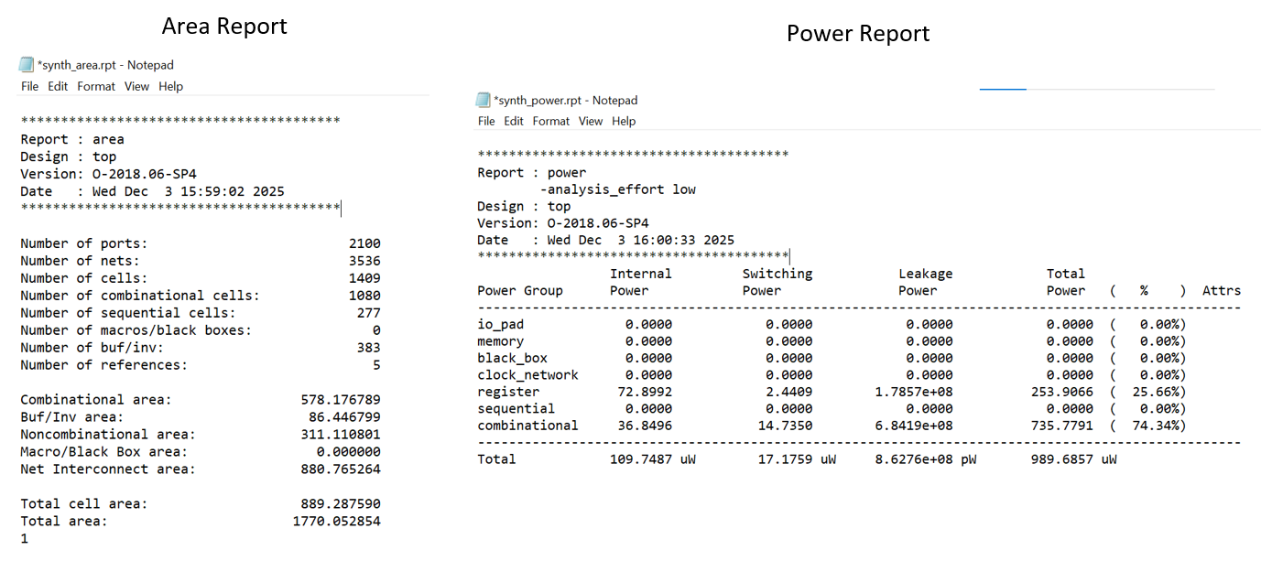

Figure 8 – Synthesized Power and Area Reports

The total cell area is 889.287590 nm² while the total area is 1770.052854 nm². Total power consumed is 989.6857 µW. These values are satisfactory for our project but could be optimized a bit further.

- Post Synthesis Static Timing Analysis

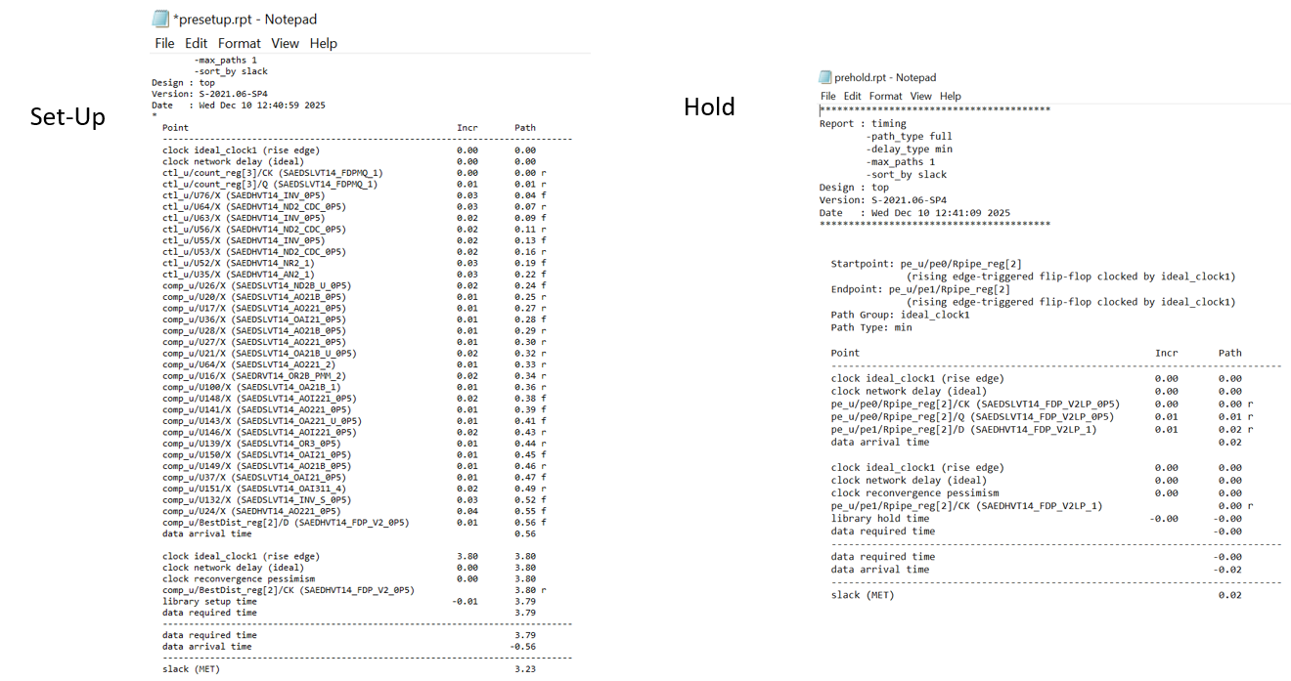

Figure 9 – Set-Up and Hold Times

Figure 9 shows our post-synthesis static timing analysis (STA). Before entering physical design, we run PrimeTime to evaluate the timing quality of the netlist. We check both setup and hold times to identify early timing violations. The reports here summarizes the worst path’s slack values, giving us a baseline before placement and routing.

Before entering the physical design stage, the first thing we do is run static timing analysis, or STA. We use PrimeTime, which is a timing verification tool that evaluates whether our design meets setup and hold requirements based on the synthesized netlist and constraints. At this stage, the design has no physical information yet—no placement, no routing, no parasitics. So this pre-layout STA gives us an initial understanding of the timing quality of our netlist.

We generate two main timing reports:
A setup timing report, which checks whether signals can arrive in time.
A hold timing report, which ensures signals do not arrive too early.
These reports help us confirm that the design is ready to move into physical implementation.

III. Physical Design

- Constraints

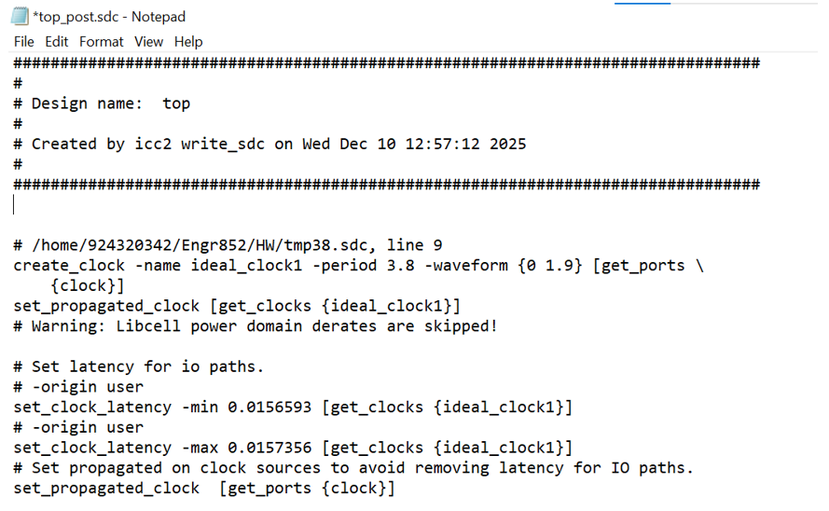

Figure 10 – Post Synthesis sdc File

Physical design follows several key stages: floorplanning, placement, clock tree synthesis, and routing.
Figure 10 provides the timing constraints used throughout these steps. It links back to the 3.8-nanosecond clock period defined in our earlier timing design, ensuring that the entire physical implementation is built on consistent timing assumptions.

Physical Design Stages
Once we finish pre-layout STA, we begin the actual physical design, using ICC2. This stage is where the netlist is transformed into a real physical chip layout.

We can divide the physical design process into several major steps:

(1) Floorplanning
We define the overall structure of the chip—its area, core boundary, and the locations of IO ports and power structures.

(2) Placement
Next, all the standard cells are placed onto the chip.
After placement, we run timing checks again, which give us updated setup and hold reports based on cell positions.

(3) Clock Tree Synthesis (CTS)
We then build the clock tree to ensure the clock signal arrives uniformly across the design.
After CTS, we evaluate the clock quality and check timing again.

(4) Routing
Finally, we route all the wires that connect the cells.
This includes global routing, detailed routing, and routing optimization.
After routing, we generate a complete set of reports—area, power, QoR, utilization, and updated timing reports.
By the end of this stage, the design is fully placed and routed, but not yet analyzed with real parasitics.

- Power and Area

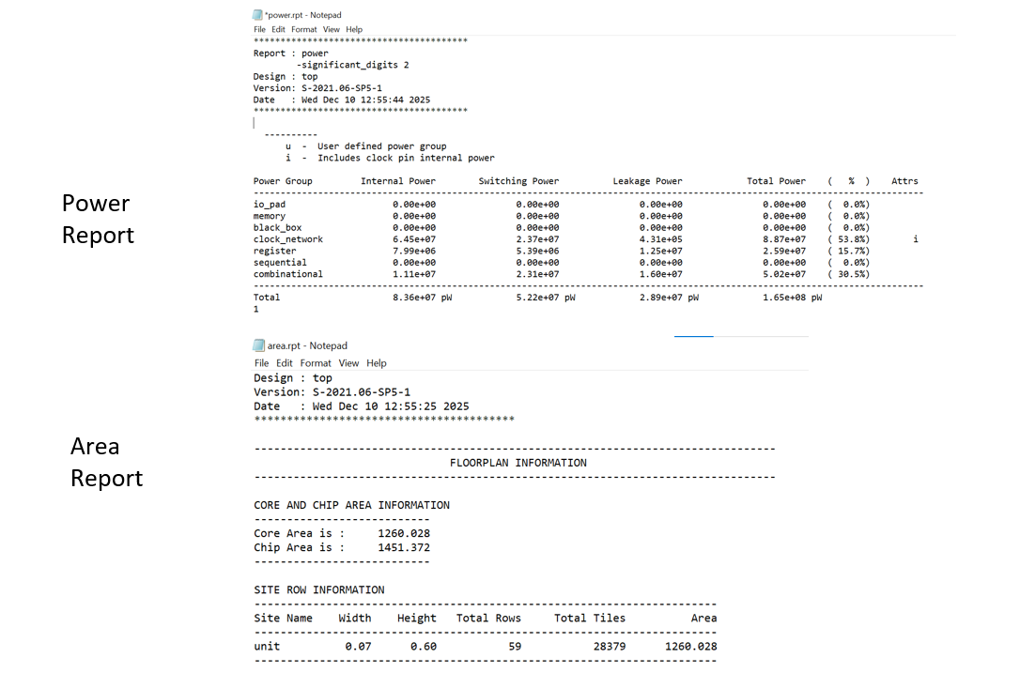

Figure 11 – Post Synthesis Power and Area Reports

Figure 11 show the physical design power and area reports. Compared with the synthesis results, the metrics changed because placement, routing, and real parasitics were introduced. These reports provide a more accurate view of the chip’s final power consumption and physical area. Core area: 1260.028 nm², Chip Area: 1451 nm², Total Power: 1.65e8 pW. These values are suspiciously lower than the pre-synthesis values which is abnormal. We chalked it up to error in the estimation process in the pre synthesis reports.

- ^{Board}
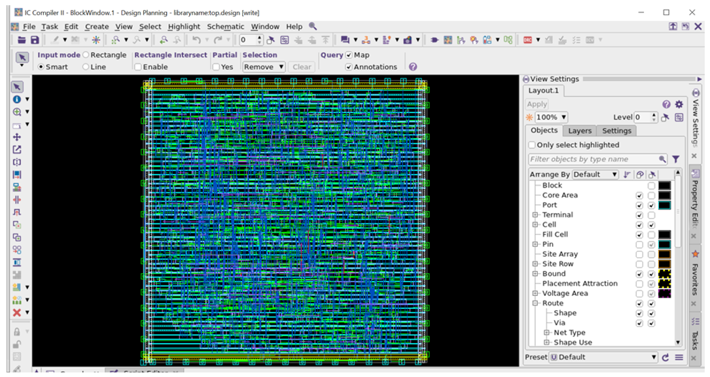
Figure 12 – Physical Design Board

Figure 12 shows the ICC2 layout board, displaying the placed cells and routed interconnects that form the final physical chip structure of our design.

- ^{Output}
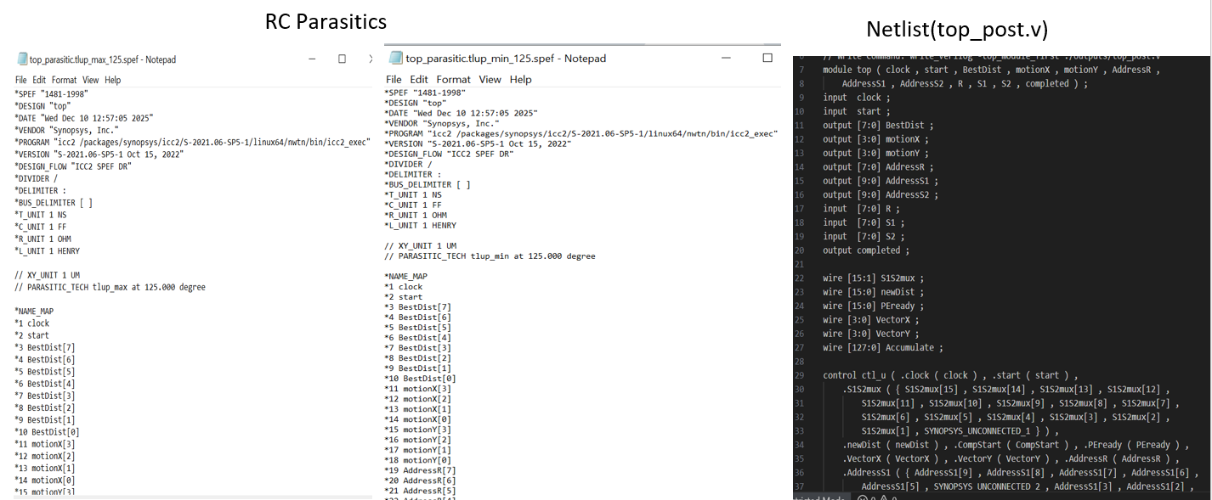

Figure 13 – Physical Design Output

Figure 13 shows the physical design outputs. After routing, we extract detailed RC parasitics for both max and min corners, capturing real wire resistance and capacitance. After extracting these parasitics, ICC2 generates a post-layout netlist and updated SDC. This netlist reflects the actual routed design and is used for final timing analysis in PrimeTime.
Once routing is complete, we extract the actual parasitic effects from the layout.
These parasitics—such as real wire capacitance and resistance—have a direct impact on timing.
We generate an extracted version of the design, including: a post-layout netlist, a post-layout SDC, and
a SPEF file containing parasitic information. This extracted data allows us to run a much more accurate timing analysis.

^{IV. Sign Off}
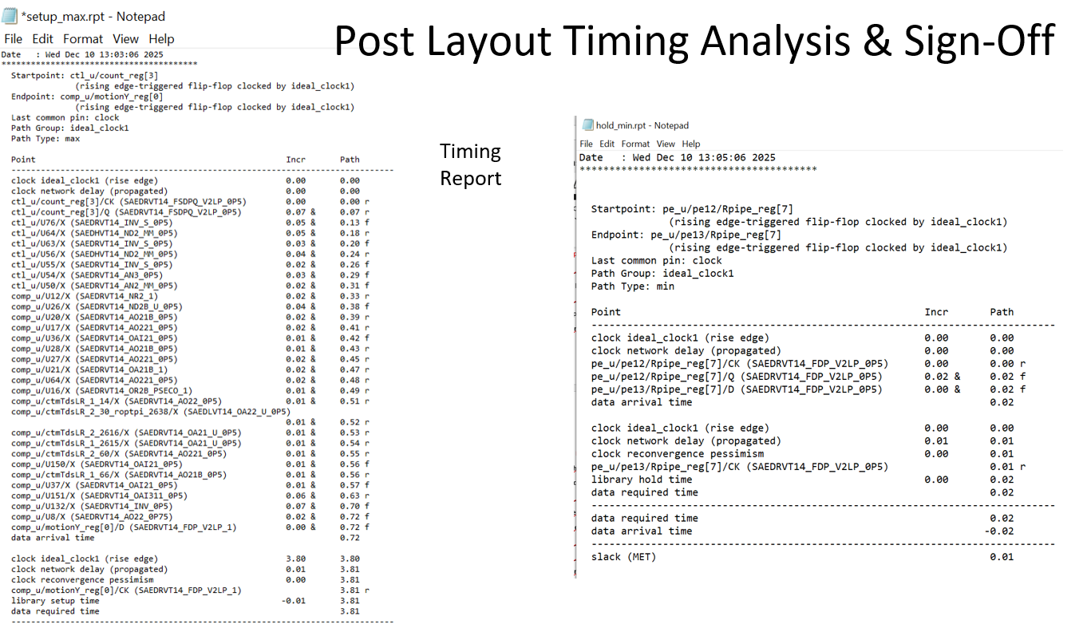

Figure 14 – Post Layout Timing Analysis & Sign-Off

Using the extracted parasitics from the SPEF files together with the post-layout netlist, we perform final setup and hold analysis in PrimeTime. This post-layout STA reflects actual routed delays, including wire resistance and capacitance. The reports shown here in Figure 14 represent our sign-off results, confirming timing closure for both the MAX corner (setup) and the MIN corner (hold).

Post-layout STA
After combining the layout parasitics with the netlist and constraints, we perform post-layout timing signoff in PrimeTime.
Here we analyze two corners:
(1) The MAX delay corner
Used for checking setup timing, ensuring signals can travel fast enough across long wires with parasitic loading.

(2) The MIN delay corner
Used for hold timing, ensuring signals do not arrive too early due to short paths.
At the end of this stage, we produce two final signoff reports:
A post-layout setup timing report
A post-layout hold timing report
These reports represent the true timing behavior of the chip and determine whether the design is ready for tape-out.

Discussion: Overall, this project showed that a block-matching motion estimator can be implemented as a relatively small, timing-closed ASIC using an industry-standard 32/28 nm flow, while still exposing several non-idealities and open questions. Functionally, the VCS simulations with worst, better, and best cases confirmed that the controller, PE array, and comparator interact correctly: the design cleanly distinguishes between “no match” (BestDist = 255), “almost found” (BestDist = 2), and a perfect match (BestDist = 0), which gives strong evidence that the search window is being scanned as intended and that the distortion metric is implemented correctly.
From a physical perspective, synthesis and pre-layout STA showed that the design can meet a 3.8 ns clock period in the chosen technology, which is slightly more aggressive than the nominal 260 MHz target and suggests that the 16-PE pipelined architecture is fast enough to support the required frame rate, assuming reasonable control overhead. Post-layout results in ICC2 and PrimeTime further confirmed that setup and hold constraints are satisfied even after routing and parasitic extraction, indicating that there are no hidden critical paths that only appear once wiring is modeled.
On the other hand, the discrepancy between pre-synthesis and post-layout power estimates—where post-layout power appears unrealistically lower—highlights limitations in our power analysis flow, such as simplified switching activity assumptions and possible mis-configuration of reporting units, and would need to be resolved in a real tape-out scenario. Finally, while the achieved area and power numbers are acceptable for the course project, they were not aggressively optimized; future work could explore alternative search strategies, deeper pipelining, or clock-gating to trade off area, power, and throughput more systematically, as well as expand the testbench (more image patterns and corner cases) to increase coverage and further validate the robustness of the motion estimator architecture.

Conclusion: By following the ASIC Design Flow, we were able to successfully implement a Motion Estimator capable of drastically reducing video compression time using the Block- Matching Algorithm. The RTL Code we had designed showed successful results using both Waveform Simulation and FPGA Emulation. By the end of this project, we had designed a fully operational low power/area chip capable of performing the task we were assigned.
To summarize:
We start with pre-layout STA to verify the netlist. Then we go through the physical design process—floorplan, placement, CTS, and routing—evaluating timing along the way. After routing, we extract real parasitics from the layout. Finally, we run post-layout STA, which incorporates those parasitics and generates our final timing signoff. This complete flow ensures that the design meets timing requirements under realistic conditions before it can move to manufacturing.

